By Qingdao Magene Intelligence Technology Co., Ltd.
Effective from October 9, 2022
Published on September 30, 2022
Material Selection, Dimension/Tolerance Design, and Inspection Specifications for Buckles

Q/MG 04070-2022

Q/MG
Enterprise Standard of Qingdao Magene Intelligence Technology Co., Ltd.

Buckle Design and Inspection Specifications
  - Scope
This document specifies the general rules, material requirements, dimensions, and tolerance requirements for the buckle structure produced by injection molding.
This document is applicable to the buckle structures of bike computers, lights, meters, and other products designed or purchased by Magene.
This standard may also apply to the dimensions and tolerances of buckles not produced by injection molding, but the fit tolerances caused by material differences shall be taken into account.
  - Normative Reference

The contents in the following documents constitute essential clauses of this document through normative references. Among them, for dated references, only the version corresponding to the date applies; for undated references, the latest version (including all amendments) applies.
Q/MG 04022 Plastic Parts
  - Composition and Part Names
1) Names of parts of the lower housing buckle:
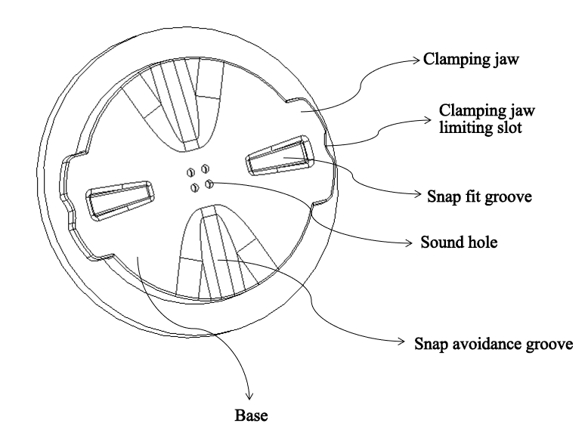
Figure 1
2) Names of parts of the holder buckle base:
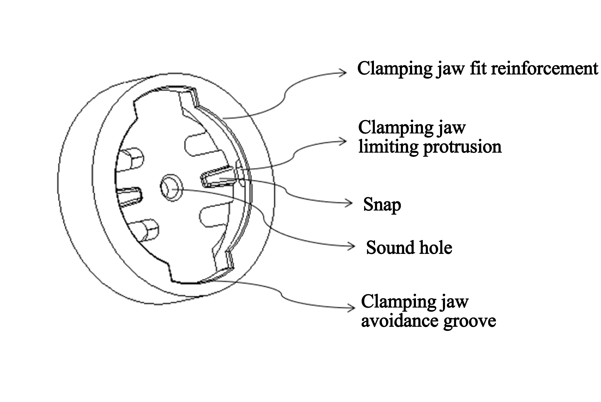
Figure 2
  - Requirements

4.1 General Rules
1) The mechanical properties and appearance of other materials of the lower housing parts of the injection molding buckle and the holder parts shall meet the requirements of Q/MG 04022 Plastic Parts.
2) The shock durability of the holder shall meet the requirements of the product reliability standard Q/MG 03003 Reliability Test Specifications for Bike Computer and Light Products.
3) The dimensions, tolerances and material selection of buckles and buckle bases in the lower housings and holders of different products shall be explicitly designated in the drawings according to the requirements of this Standard, and the dimensions and tolerances cannot be changed if not necessary
4) The dimensions marked with * in Section 4.3 are the key dimensions that affect the fit torque of the buckle and the buckle holder, and such dimensions must be checked after mass production.

4.2 Material Requirements
The buckle and the holder material designations shall be selected according to the requirements in Table 1.
Material selection principles:
- The material added with glass fiber is visible to a certain extent. Products with special appearance requirements shall be evaluated and selected.
- PA6+10%GF is preferred for the buckle base holder.
- The above preferred material is recommended for its greater stability.

4.3 Dimensions and Tolerance Requirements
1) Refer to Table 2 and Table 3 for the dimensions and tolerance requirements of the buckle and the buckle holder.
2) The specified dimensions and tolerance shall strictly follow the requirements in the Tables and shall not be changed if not necessary.
3) All the parts shall be inspected according to the following dimensions and tolerance requirements prior to mass production.
4) The parts after mass production shall be inspected according to the dimensions marked with *. Additionally, the dimensions marked with * shall be designated as the required inspection items in the design drawings as per the requirements in the Tables.
5) The dimensions marked with "()" below are reference dimensions for R&D and design, which are optional in inspection.

Table 2 Dimensions and Tolerance Requirements of Buckle
Bike Computer Buckle | Top View | Side view:
 | 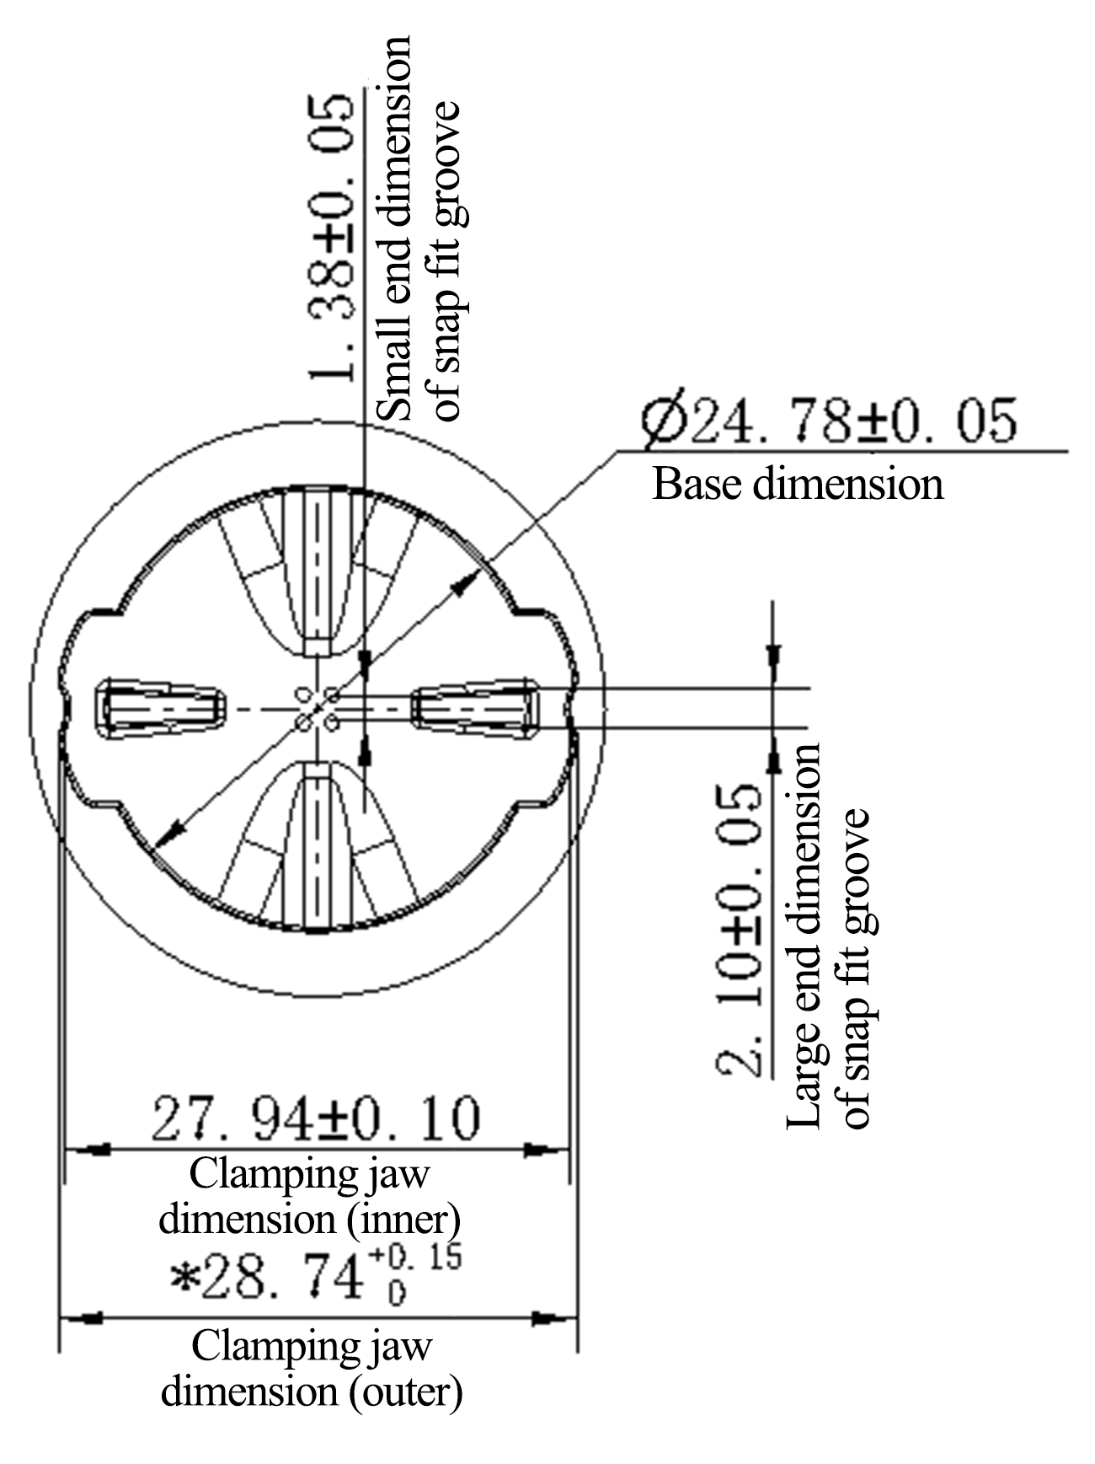 | 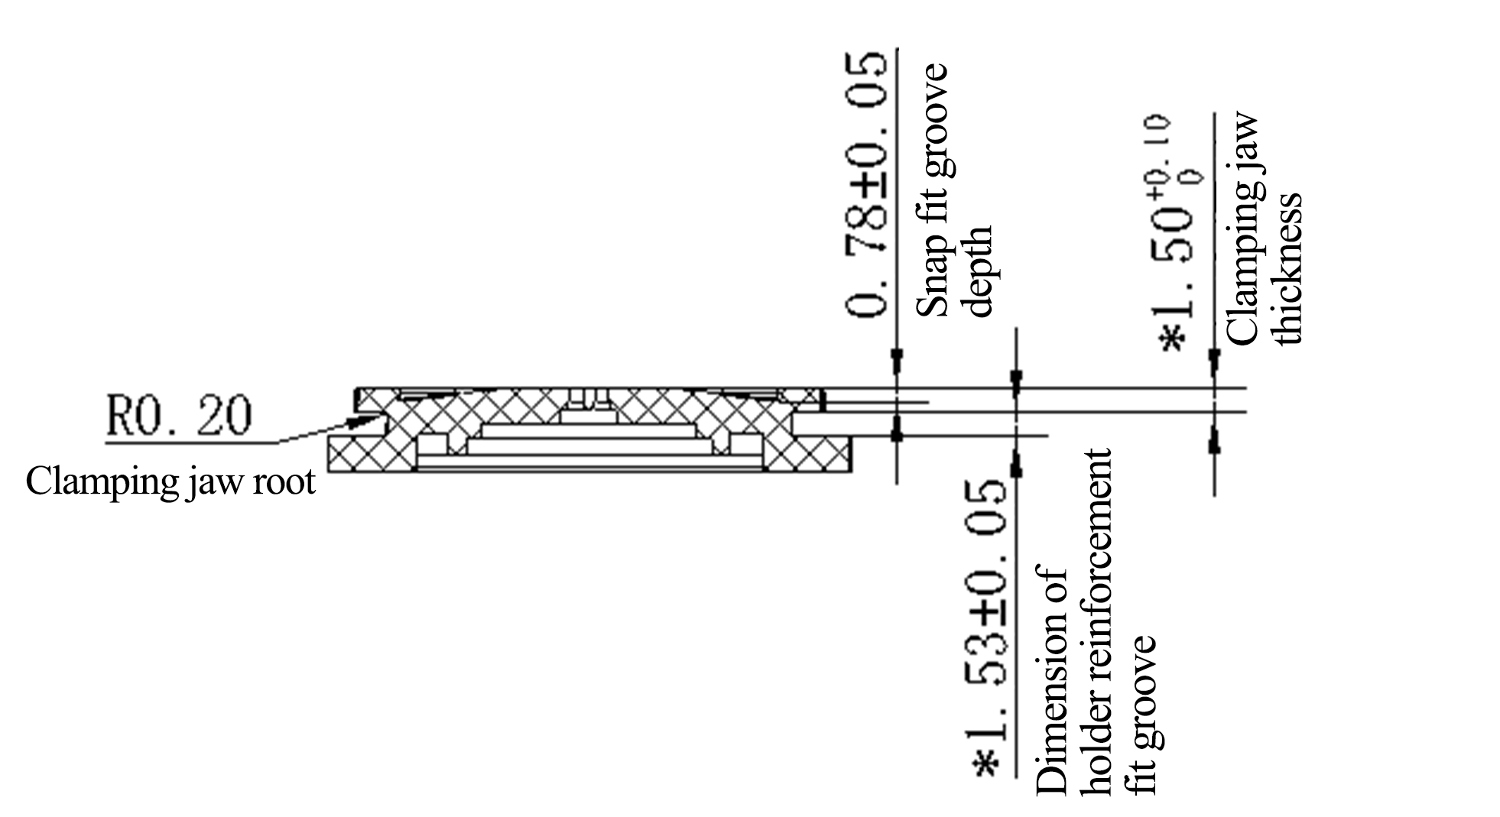

Table 3 Dimensions and Tolerance Requirements of Holder Buckle Base
Holder Buckle Base of Bike Computer | Top View | Side view:
 | 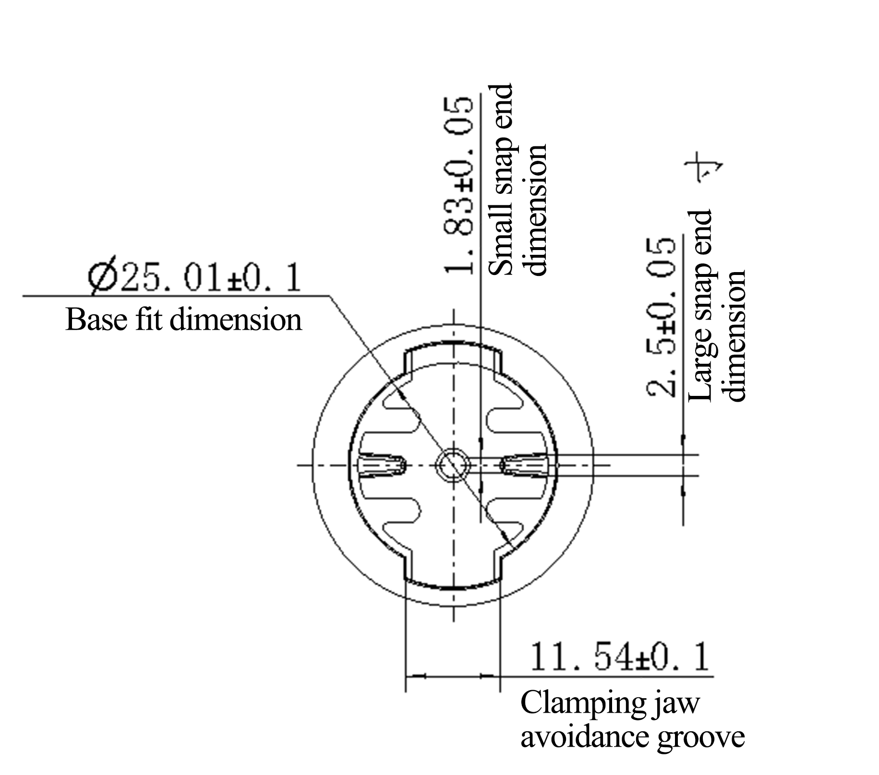 | 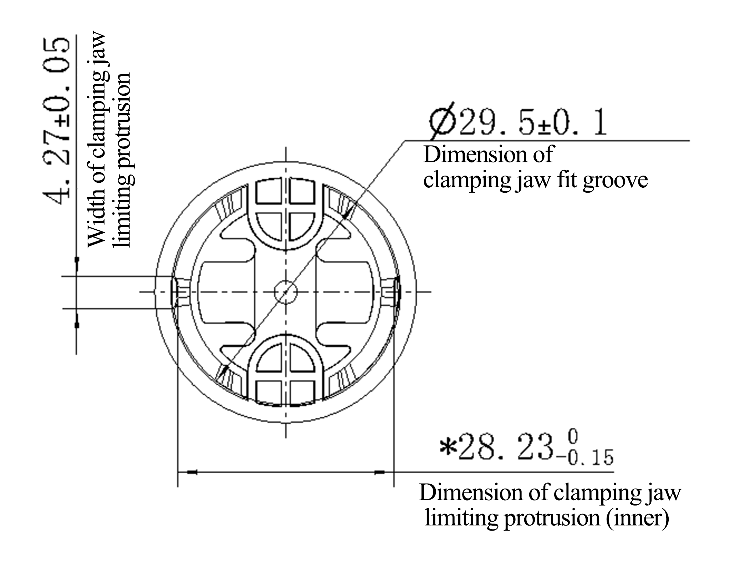
 | Sectional View - Include an Additional Dimension Value
 | 